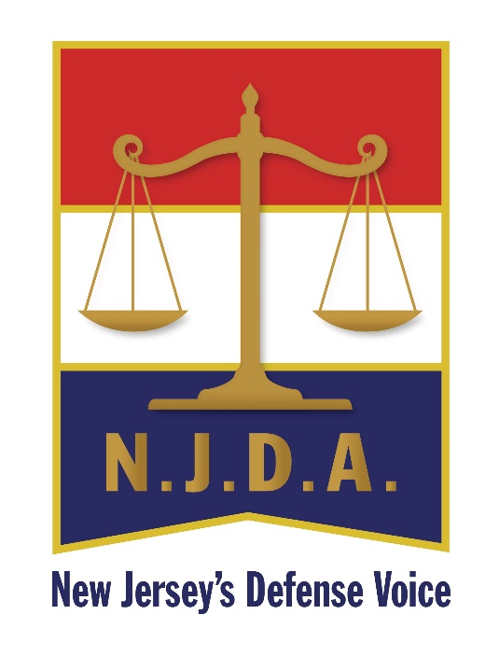

The New Jersey Defense Association is seeking nominations for submission to the Board of Directors for the following awards:
Young Lawyer of the Year 2023-2024
Attorney of the Year 2023-2024
The following criteria will be considered by the Board:
Young Lawyer: Age 40 or less, or with less than 10 years of experience.
Young Lawyer and Attorney of the Year Nominations:
- Must be a member in good standing of the NJDA.
- The nominee must have made a substantial contribution to the NJDA and the legal community by means of participation in NJDA sponsored events; Seminar presentation; publication of legal articles; performance of charitable works and/or pro bono representation.

Please submit all nominations to Maryanne Steedle, Executive Director, no later than June 1, 2023.
Please send nomination letters to P. O. Box 463, Linwood, NJ 08221 or email to njda@comcast.net

